**Sales Analysis**

#First table let’s see how much we sale per year

SELECT EXTRACT(YEAR FROM occurred_at) AS year, SUM(total_amt_usd) AS total_usd

FROM orders

GROUP BY year

ORDER BY total_usd ASC

````

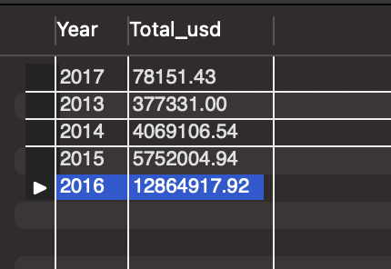’

We observe that in 2013 and 2017 there were less sales, but except for them, sales have been increasing year after year and that 2016 is the year with the most sales.

#The next table shows that for 2013 and 2017 there is only one month of sales for each of these years.

SELECT

year (occurred_at) as Year, month(occurred_at) as month,

sum(total_amt_usd) as total_usd

from orders

where year (occurred_at)=2013 or year (occurred_at)=2017

group by year (occurred_at), month(occurred_at)

order by year (occurred_at)

#If we dig a little deeper, we can see that only two days are registered in 2017, the first and second day of January.

SELECT EXTRACT(YEAR FROM occurred_at) AS year,

EXTRACT(MONTH FROM occurred_at) AS month, EXTRACT(DAY FROM occurred_at) AS day,

SUM(total_amt_usd) AS total_usd

FROM orders

WHERE EXTRACT(YEAR FROM occurred_at)=2017

GROUP BY year, month, day

ORDER BY total_usd ASC

#Now we compare the total in January 1rst of every year.

Note that year-on-year there has been a steady increase in sales.

SElECT EXTRACT(YEAR FROM occurred_at) AS year,

EXTRACT(MONTH FROM occurred_at) AS month, EXTRACT(DAY FROM occurred_at) AS day,

SUM(total_amt_usd) AS total_usd

FROM orders

WHERE EXTRACT(YEAR FROM occurred_at)=2017

GROUP BY year, month, day

ORDER BY total_usd ASC

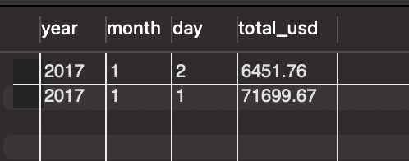

#Now we compare the total in January 1rst of every year.

Note that year-on-year there has been a steady increase in sales.

SELECT EXTRACT(YEAR FROM occurred_at) AS year, EXTRACT(MONTH FROM occurred_at) AS month, EXTRACT(DAY FROM occurred_at) AS day,

SUM(total_amt_usd) AS total_usd

FROM orders

WHERE EXTRACT(MONTH FROM occurred_at)=1 AND EXTRACT(DAY FROM occurred_at)=1

GROUP BY year, month, day

ORDER BY total_usd ASC

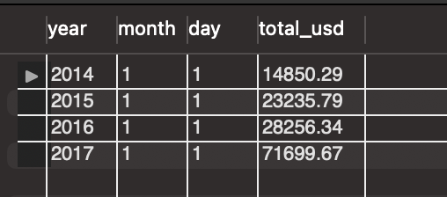

#In the table below we can see how much our sales grew by year

WITH CTE_GROWTH AS (

SELECT YEAR(occurred_at) AS year,

MONTH(occurred_at) AS month,

DAY(occurred_at) AS day,

SUM(total_amt_usd) AS total_usd

FROM orders

WHERE MONTH(occurred_at) = 1 AND DAY(occurred_at) = 1

GROUP BY year, month, day

ORDER BY total_usd ASC

)

SELECT year, month, day, total_usd,

total_usd - LAG(total_usd) OVER (ORDER BY year ASC) AS growth,

(total_usd - LAG(total_usd) OVER (ORDER BY year ASC)) / LAG(total_usd) OVER (ORDER BY year ASC) * 100 AS percentage_growth

FROM CTE_GROWTH;

From 2016 to 2017 our sales grew 153\%.

#For each account we determine the average amount of each type of paper each company purchased across their orders.

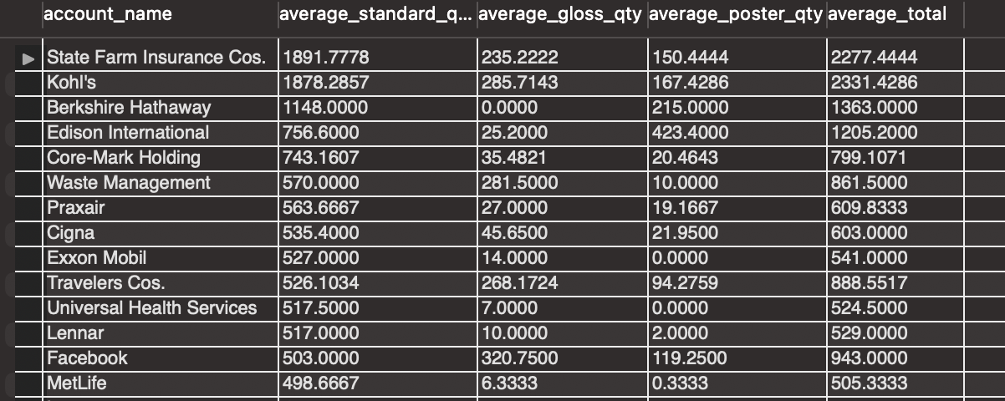

The company that has bought us more quantity of paper is *State Farm Insurance Cos.*

#Now we determine the average amount spent per order on each paper type.

SELECT ac.name AS account_name, AVG(o.standard_amt_usd) AS avg_standard_amt_usd, AVG(o.gloss_amt_usd) AS avg_gloss_amt_usd,

AVG(o.poster_amt_usd) AS avg_poster_amt_usd, AVG(o.standard_amt_usd)+AVG(o.gloss_amt_usd)+AVG(o.poster_amt_usd) as total

FROM accounts ac JOIN orders o ON ac.id=o.account_id

GROUP BY ac.name

ORDER BY total DESC

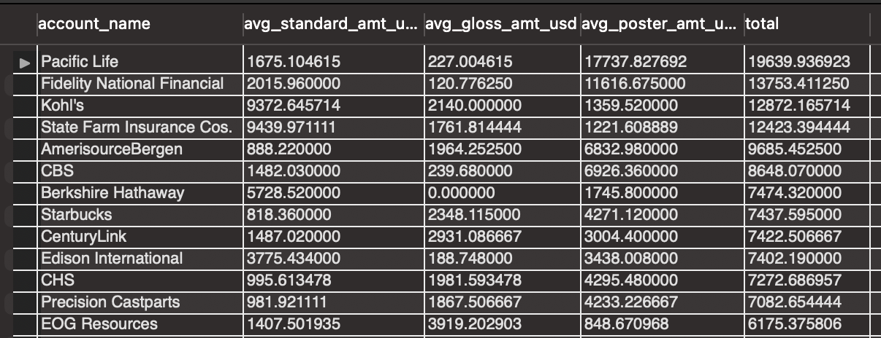

From the table above we observe that *Pacific Life* is the company who has bought us the most, followed by *Fidelity National Financial.*

With an analogous procedure we obtain the companies that have bought the least from us. In this case, *Nike.*

Also, if we are interested in a specific type of paper, we can sort the previous table; for example, let's say we are interested in standard paper, then we sort by the avg_standard_amt_usd column, and in this way, we can see who has spent the most on that type of paper.

#For now, lets see how much paper we have sold.

SELECT SUM(standard_qty) AS total_standard_qty,

SUM(gloss_qty) AS total_gloss_qty,

SUM(poster_qty) AS total_poster_qty,

FROM orders

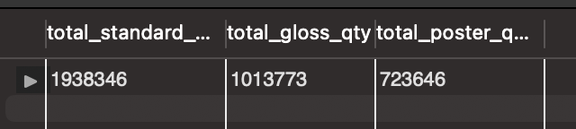

SELECT SUM(standard_qty) AS total_standard_qty,

SUM(standard_amt_usd) AS total_standard_usd,

SUM(gloss_amt_usd) total_gloss_usd,

SUM(poster_amt_usd) AS total_poster_usd

FROM orders

From the two tables above we observe that the paper that has sold the most is standard paper.

#Let's say we want to know the unit price that each company paid per order, but only for those that have bought more than 100 standard type papers and 50 poster papers.

SELECT r.name AS region,

ac.name AS account_name,

o.total_amt_usd / (o.total + 0.01) AS unit_price

FROM region r

JOIN sales_reps sr ON r.id = sr.region_id

JOIN accounts ac ON sr.id = ac.sales_rep_id

JOIN orders o ON ac.id = o.account_id

WHERE o.standard_qty > 100 AND o.poster_qty > 50

ORDER BY unit_price ASC;

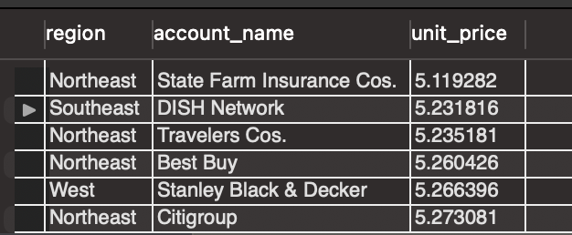

SELECT r.name as region, ac.name as account_name, o.total_amt_usd/(o.total + 0.01) as unit_price

FROM region r JOIN sales_reps sr ON r.id=sr.region_id JOIN accounts ac ON sr.id=ac.sales_rep_id JOIN orders o ON ac.id = o.account_id

WHERE o.standard_qty > 100 AND o.poster_qty > 50

ORDER BY unit_price DESC

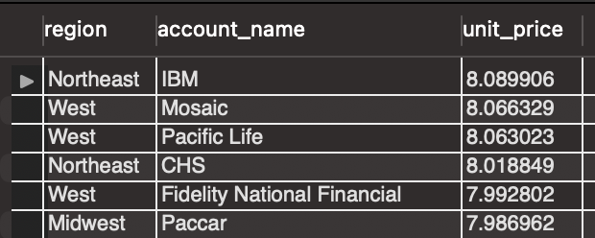

The lowest unit price is 5.11 USD and corresponds to *State Farm Insurance Cos.*, while the highest unit price is 8.08 USD, which corresponds to *IBM.*

Knowing the unit price is important because it allows the buyer to understand how the total sales amount was calculated. That is, it is a matter of transparency and providing all the necessary information to the customer.

We could also use this unit price to get an idea of the cost of producing a certain type of paper. Similarly, we can compare this unit price with that of our competitors.

**## Conclusions**

**1. Year-on-year there has been a steady increase in sales with a surge of over 100\% from 2016 to 2017.**

**2. We expect 2017 to have the largest sales.**

**3. Our biggest client is *Pacific Life* followed by *Fidelity National Financial.\***

**4. The paper that has sold the most is standard type paper.**

**5. The highest unit price is 8.08 USD, which corresponds to *IBM.\***